# Learning Outcome

# After completing this module, the student should be able to understand introduction to business.

To meet the learning outcome, a student has to complete the following activities

1. Creating linear regression model in python
2. Evaluating linear regression model
3. Performing minmax scaling and standard scaling
4. Implementing KNN in python using sklearn
5. Evaluation of KNN model in python, and visualizing results
6. Evaluating model using AUC, ROC curve

# Activity 1

## Aim: Creating Linear Regression model in Python

**Learning outcome:** Able to understand basic computer network technology.

**Duration:** 5 hour

**List of Hardware/Software requirements:**

1. …...
2. …...
3. …….

**Code/Program/Procedure (with comments):**

The steps involved are:

1. Importing the dataset.

The first and foremost thing we need to do is import the dataset. We have various websites which have these datasets to be used by anyone.

!wget 'https://archive.org/download/ages-and-heights/AgesAndHeights.pkl'

This single line of code helps us fetch the data used for the tutorial from the URL directly.

2. Visualising the Data

In this step after importing the data and mounting it with Colab let’s have an overview of the dataset by importing a Module called pandas. Since the dataset we have has an extension of .pkl we just view it by the function available in the pandas library.

import pandas as pd

raw_data = pd.read_pickle('AgesAndHeights.pkl')

raw_data

We import the library to read the dataset and store it in a variable called raw_data. We then display the content of raw_data which is in a tabulated format.

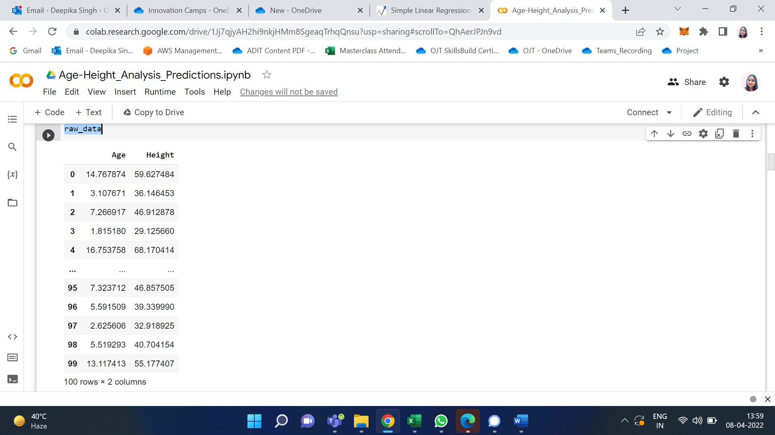

We can see the data which we have and it contains only 2 columns namely, Age (in years) and Height (in inches) and 100 rows which is actually the representation of a person.

raw_data.hist()

This single line of code has a great impact on the way we look at the dataset. We only had a numerical view of the dataset but we can now run this cell to get a histogram view of the dataset which is very helpful. It represents the data present in the individual columns as individual graphs.

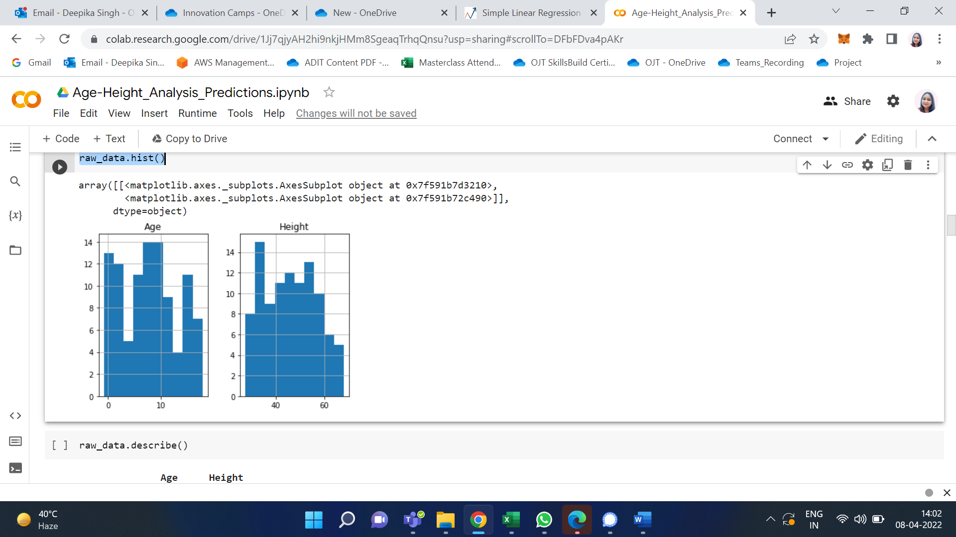

The Y-axis in both the plots refers to frequency and X-axis represents Age and Height respectively.

3. Data Cleaning

We have to build the model using valid datasets and clean the unaccountable Data. In the above image, we can know that there are a few entries that have an age less than zero which is meaningless. Hence, we need to clean those data to get better accuracy.

cleaned_data = raw_data[raw_data['Age'] > 0]

cleaned_data

I use variable cleaned_data to store the valid age values and display them to the user.

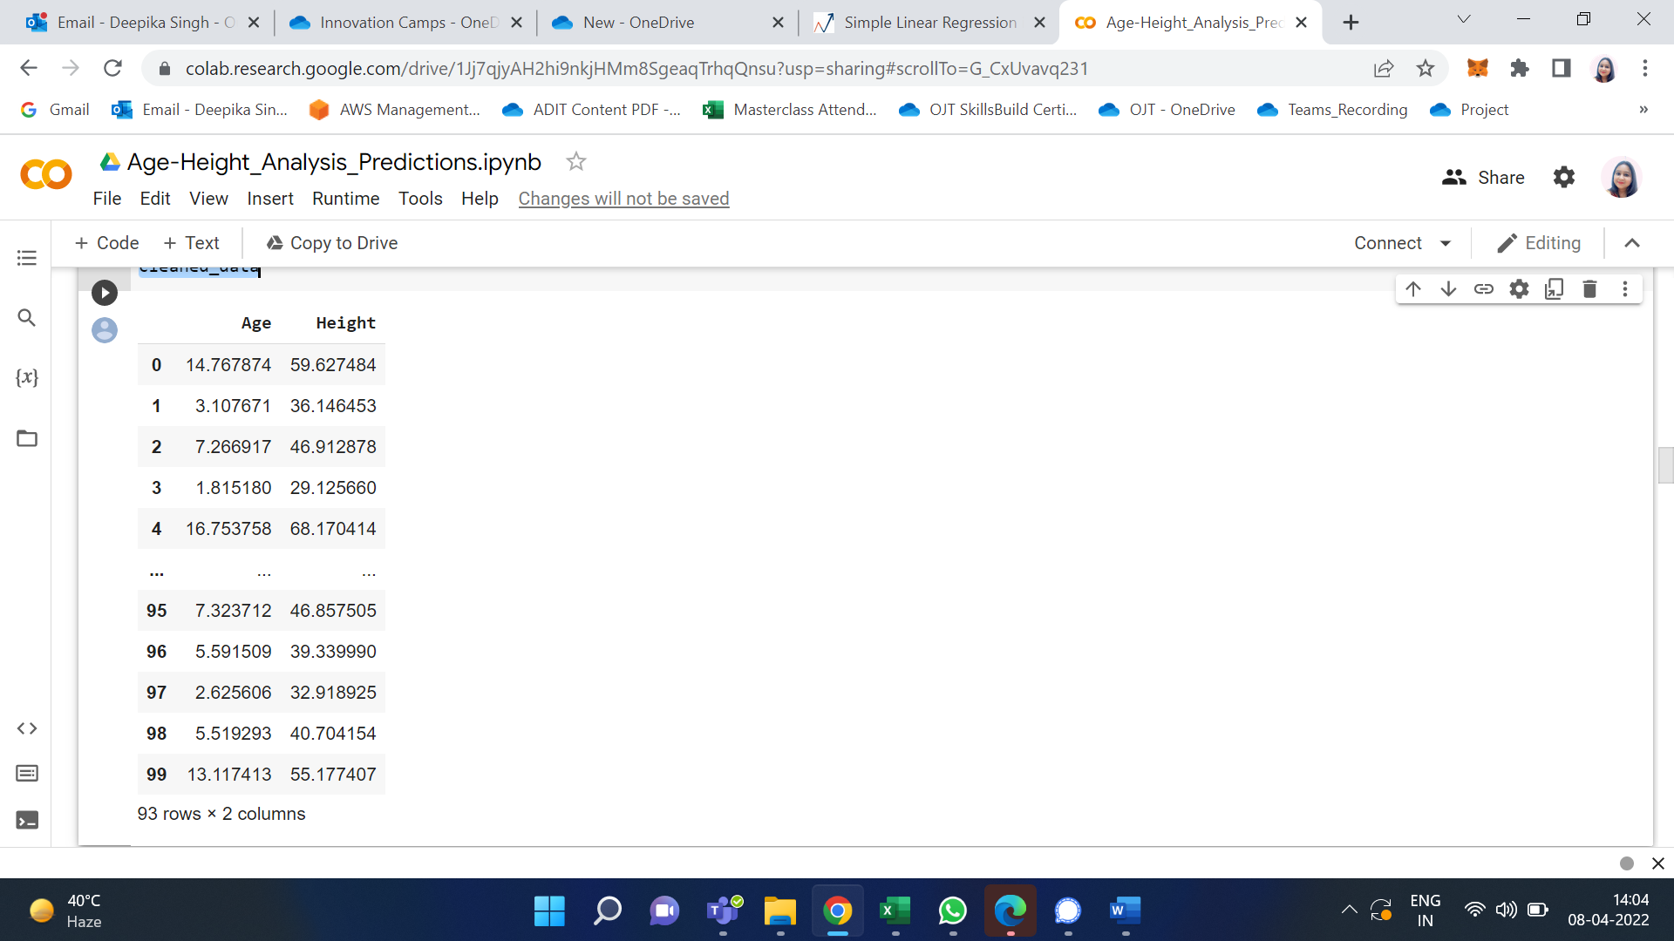

Initially, we had 100 rows but after performing Data Cleaning it’s pretty clear that there are seven rows which we had age < 0 and we have removed them. As a professional, we aren’t supposed to delete the data as we are reducing the data and thereby accuracy of our model gets reduced. To keep it simple I have just removed them.

Visualize the Cleaned Data: I have now used the cleaned data and visualized it in the form of a graph.

import matplotlib.pyplot as plt

ages = cleaned_data['Age']

heights = cleaned_data['Height']

plt.scatter(ages,heights, label='Raw Data')

plt.title('Height VS Age')

plt.xlabel('Age[Years]')

plt.ylabel('Height[Inches]')

plt.legend()

To plot graphs in python I import matplotlib.pyplot library. I represent Age on X-axis and Height on Y-axis. The points in the plot refer to the Raw data.

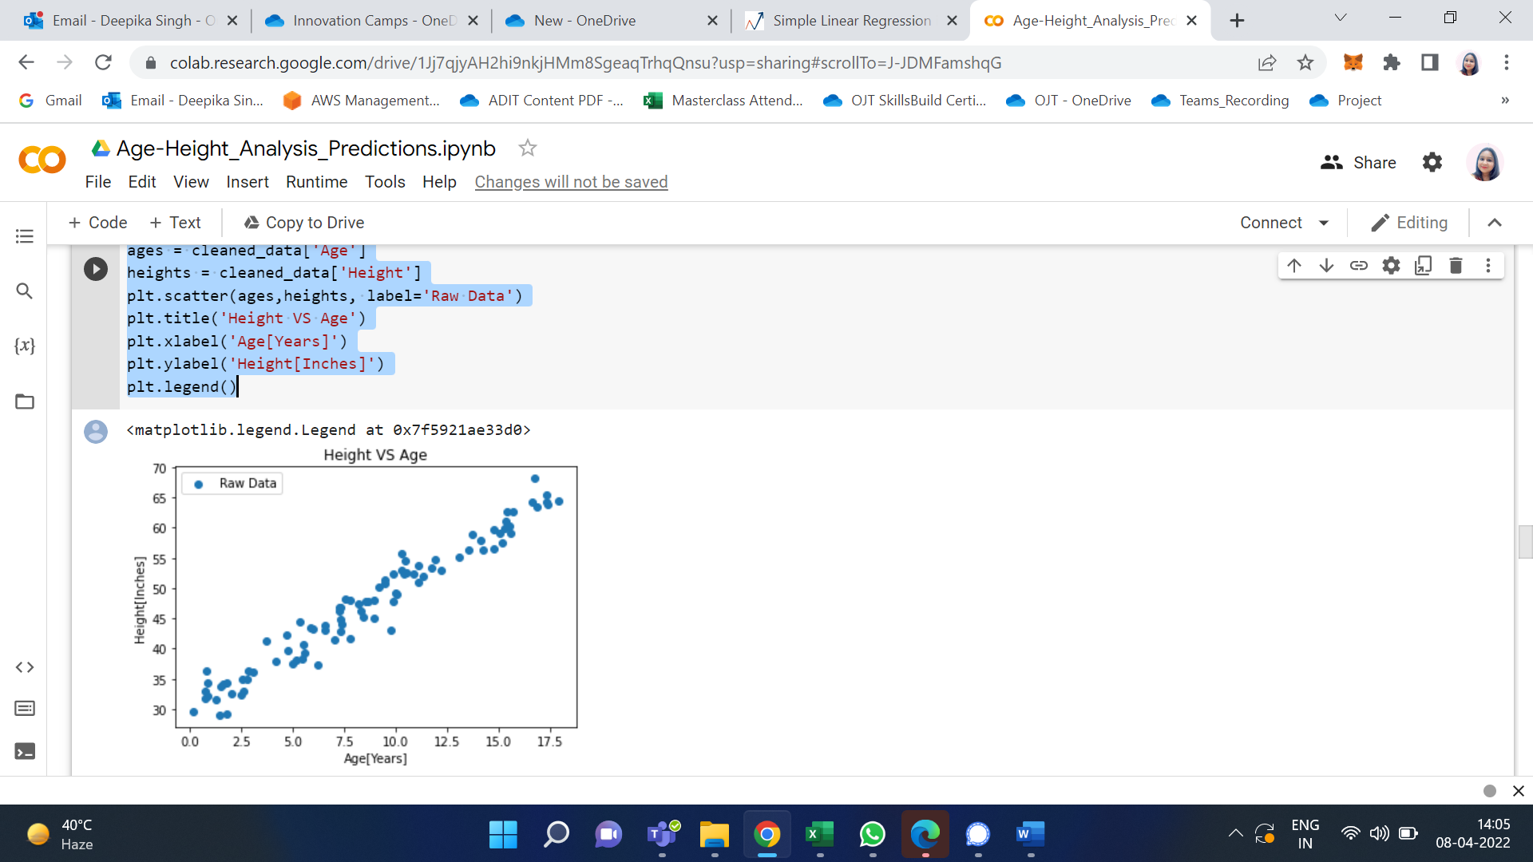

1. Build the Model and Train it

This is where the ML Algorithm i.e. Simple Linear Regression comes into play.

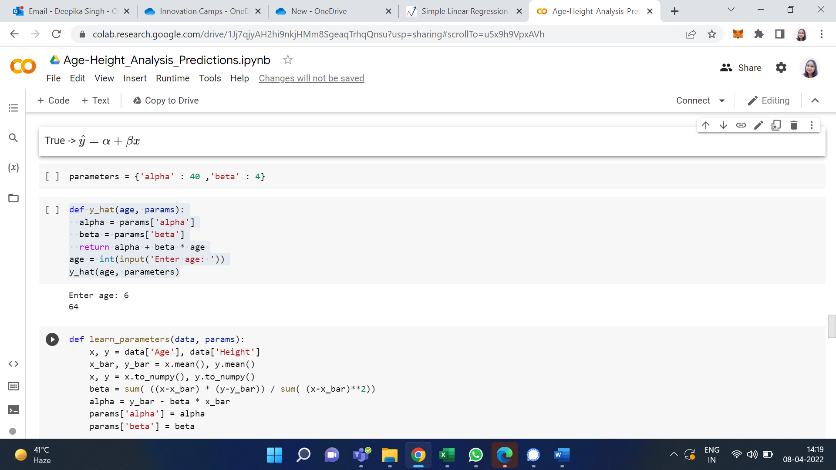

I used a dictionary named parameters which has alpha and beta as key with 40 and 4 as values respectively. I have also defined a function y_hat which takes age, and params as parameters. This function uses the basic straight-line equation and returns y i.e. height as in our case. If we pass the required parameters and run the function, we find that the height we get for the age as input is not matched. Hence, we use the function mentioned below to rain the model.

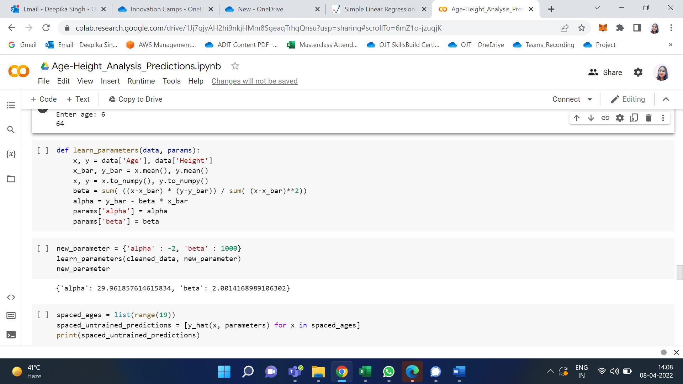

This is where we use a method to find the correct alpha and beta. The function learn_parameters takes cleaned_data and a dummy dictionary new_parameter which can have any value for alpha and beta. So, when we pass them as arguments to parameters and function runs and we can get the correct value of alpha and beta which is found to close to 30 and 2 respectively and replace the old values with the new ones.

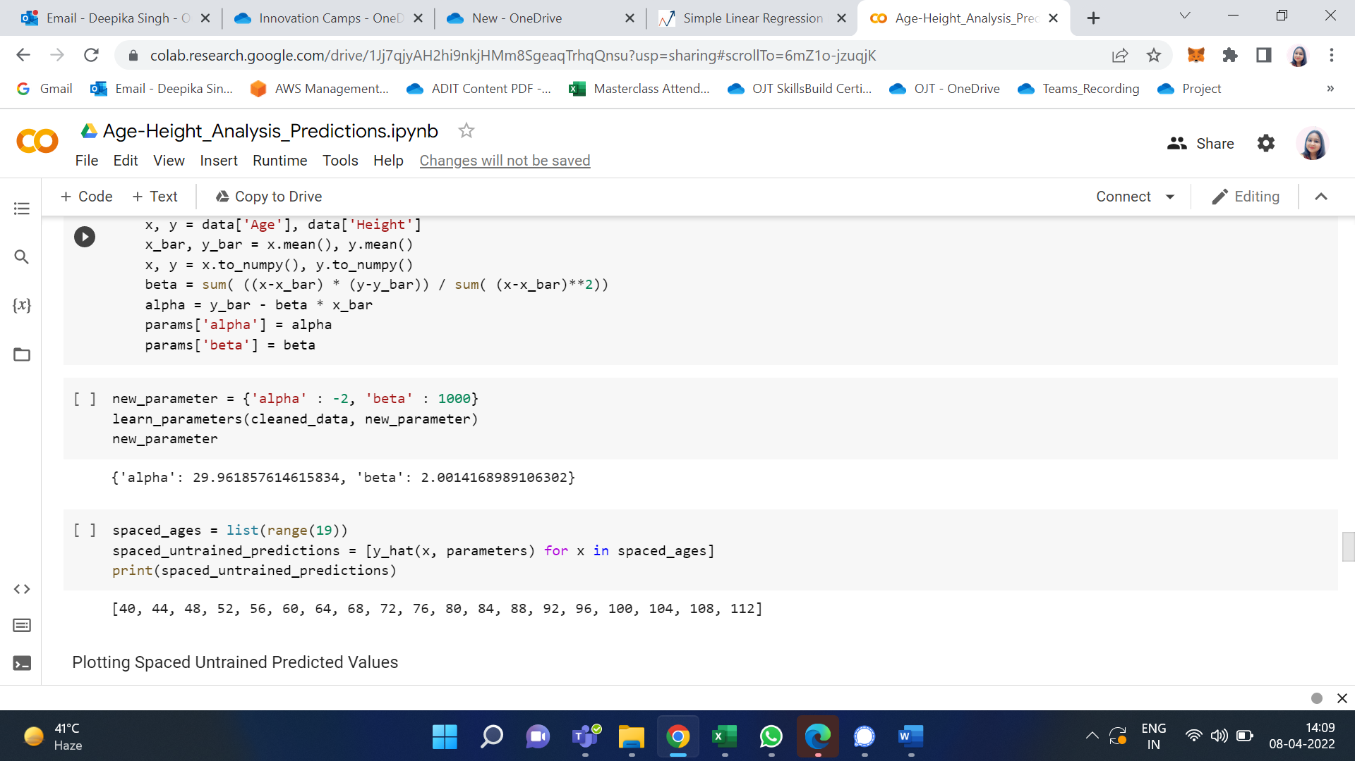

We have accurately found the values of alpha and beta, and our next goal is to train the data. But let me the untrained predicted values to what extent they are accurate.

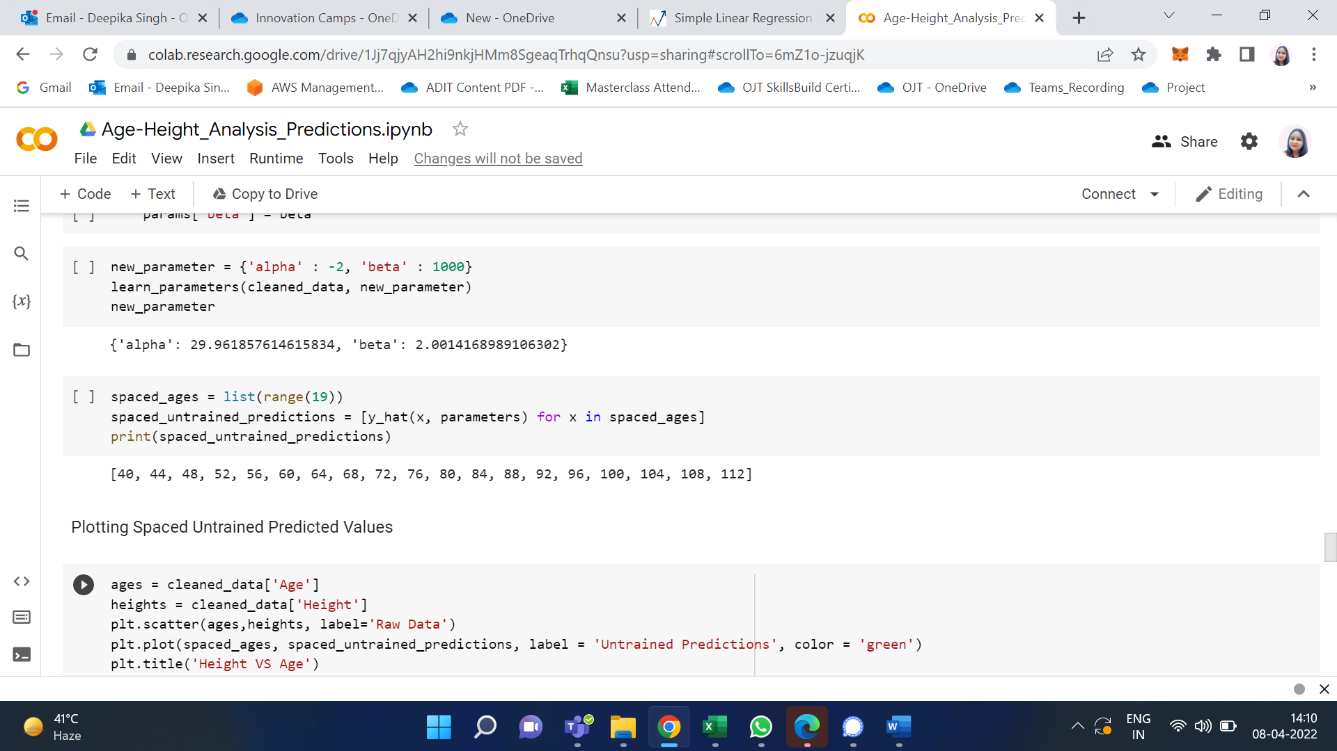

I use a list named spaces_ages that has values from 0 to 18 (end – 1). Then another list named spaced_untrained_predictions that has the predicted values for the height uses the y_hat function defined earlier to predict it. These values are plotted in a graph and visualized.

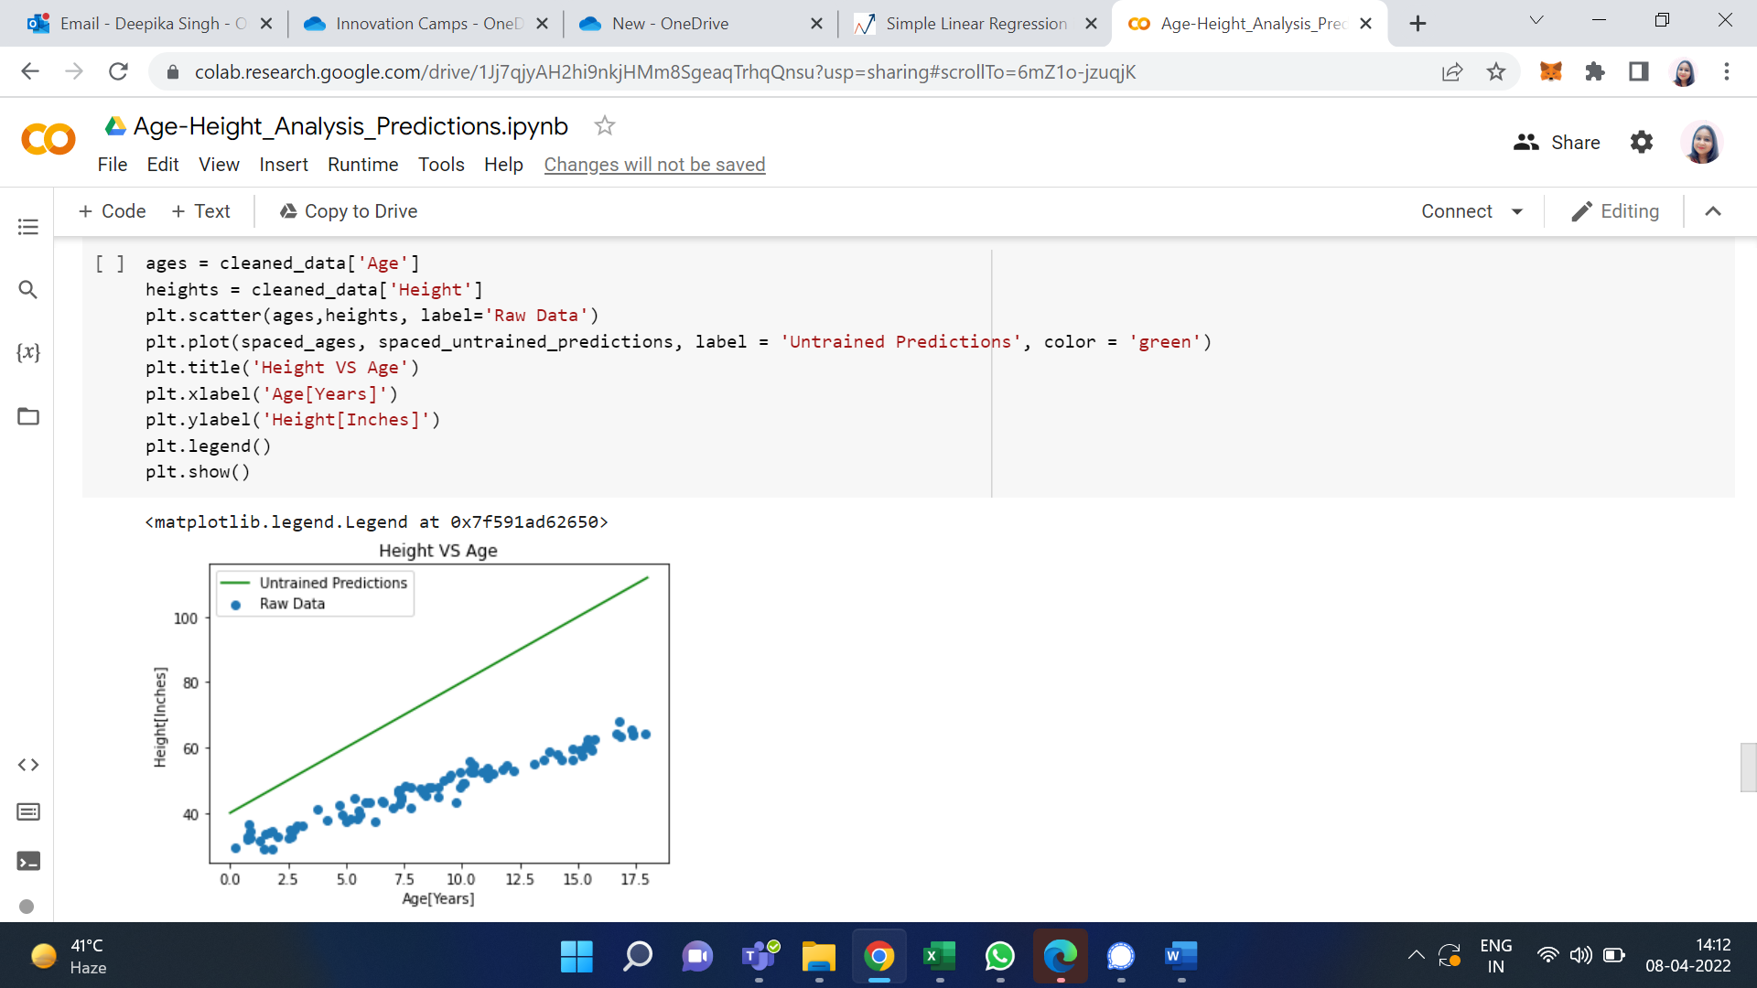

The green line shows that the spaced_untrained_predictions have largely deviated from the actual values and the accuracy is very poor. Hence, accuracy needs to be increased for which we need to train the data.

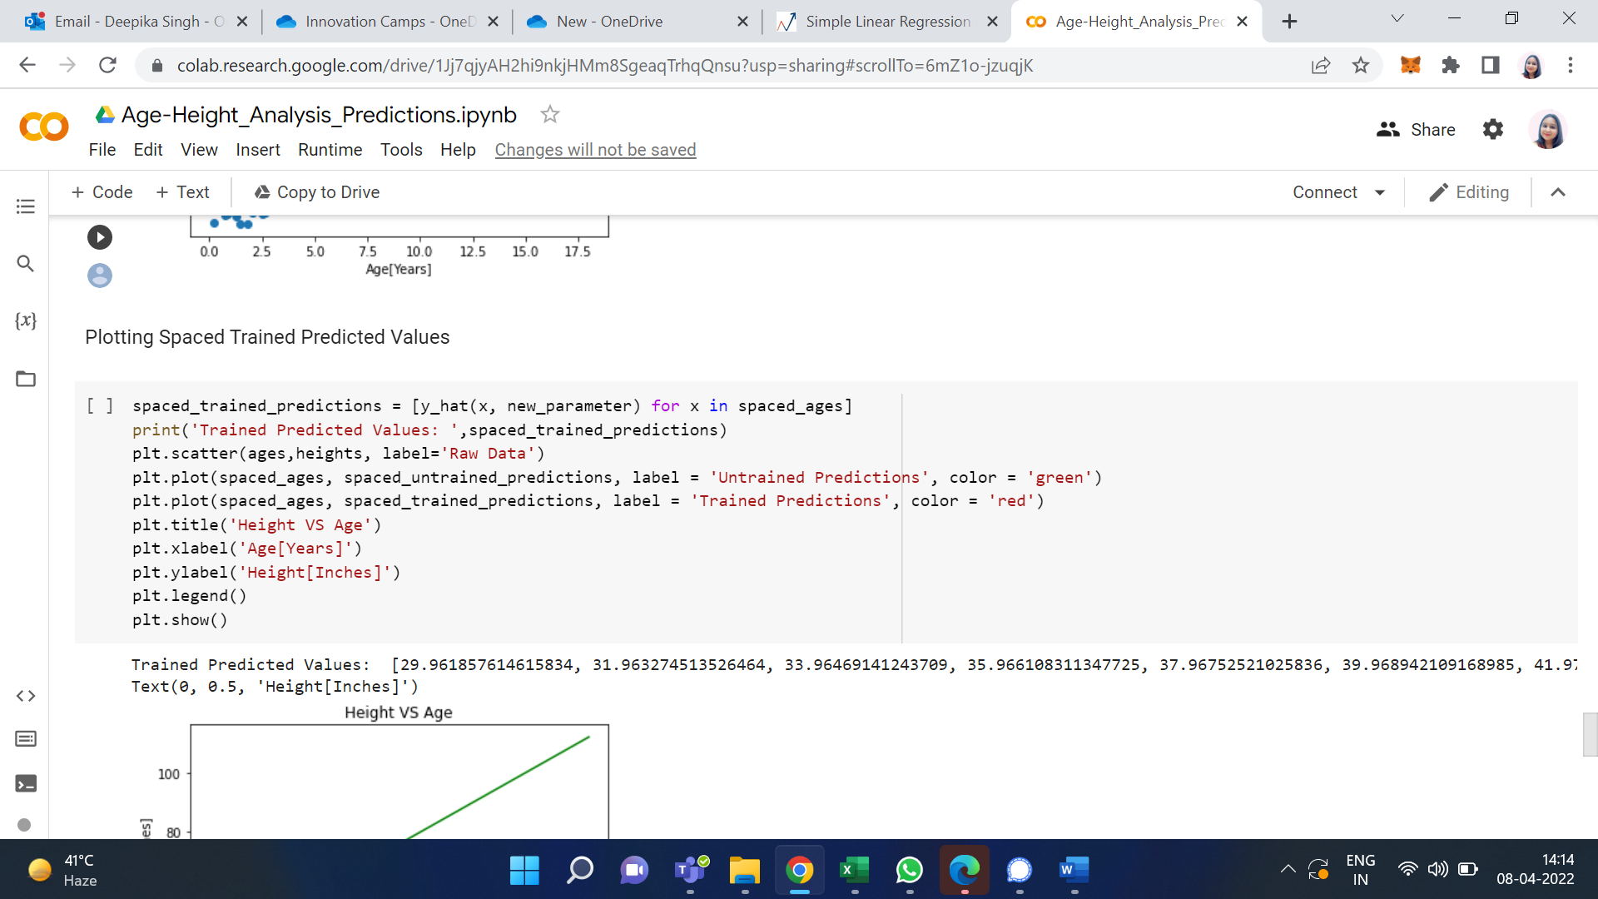

So instead of using parameters, we use new_parameters as it contains the accurate value of alpha and beta and stores it in a list named spaced_trained_predictions. So, when we plot a graph for this, we can see a visible difference and the accuracy has increased a lot. Therefore, we have successfully built and trained the model. Proof for that is the values of spaced_trained_predictions and the graph.

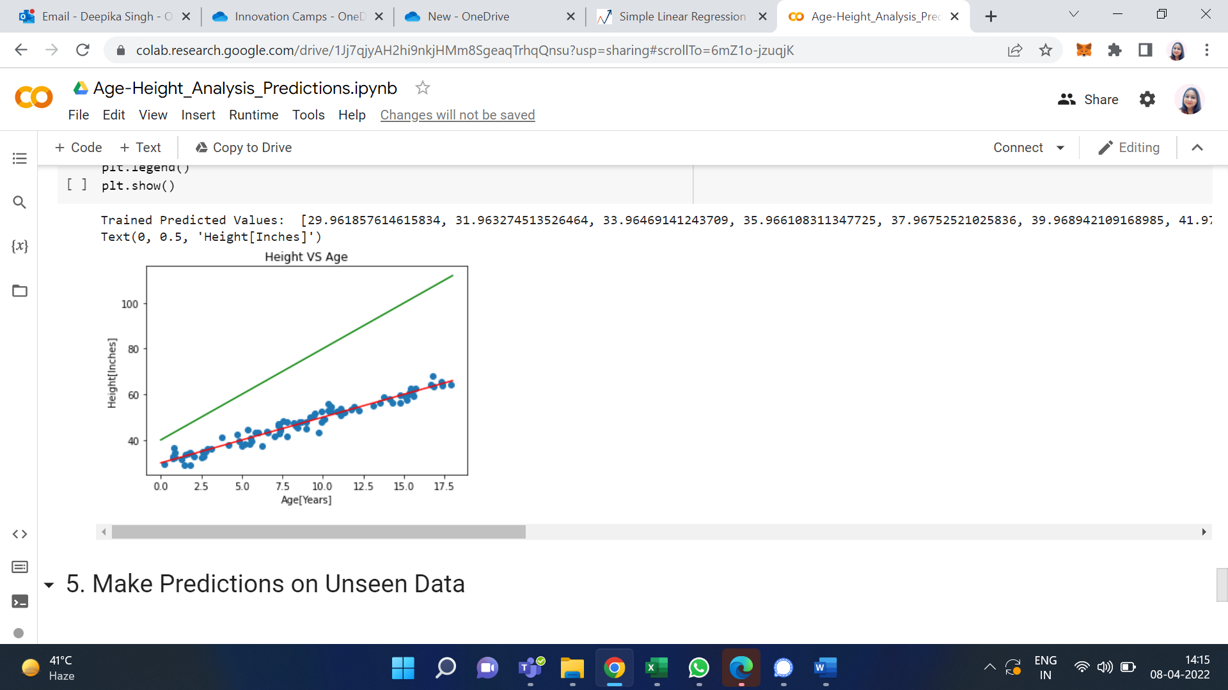

The Greenline refers to the values of spaced_untrained_predictions and Redline refers to the values of spaced_trained_predictions.

1. Make Predictions on Unseen Data

With the help of this trained model, we can now make accurate predictions.

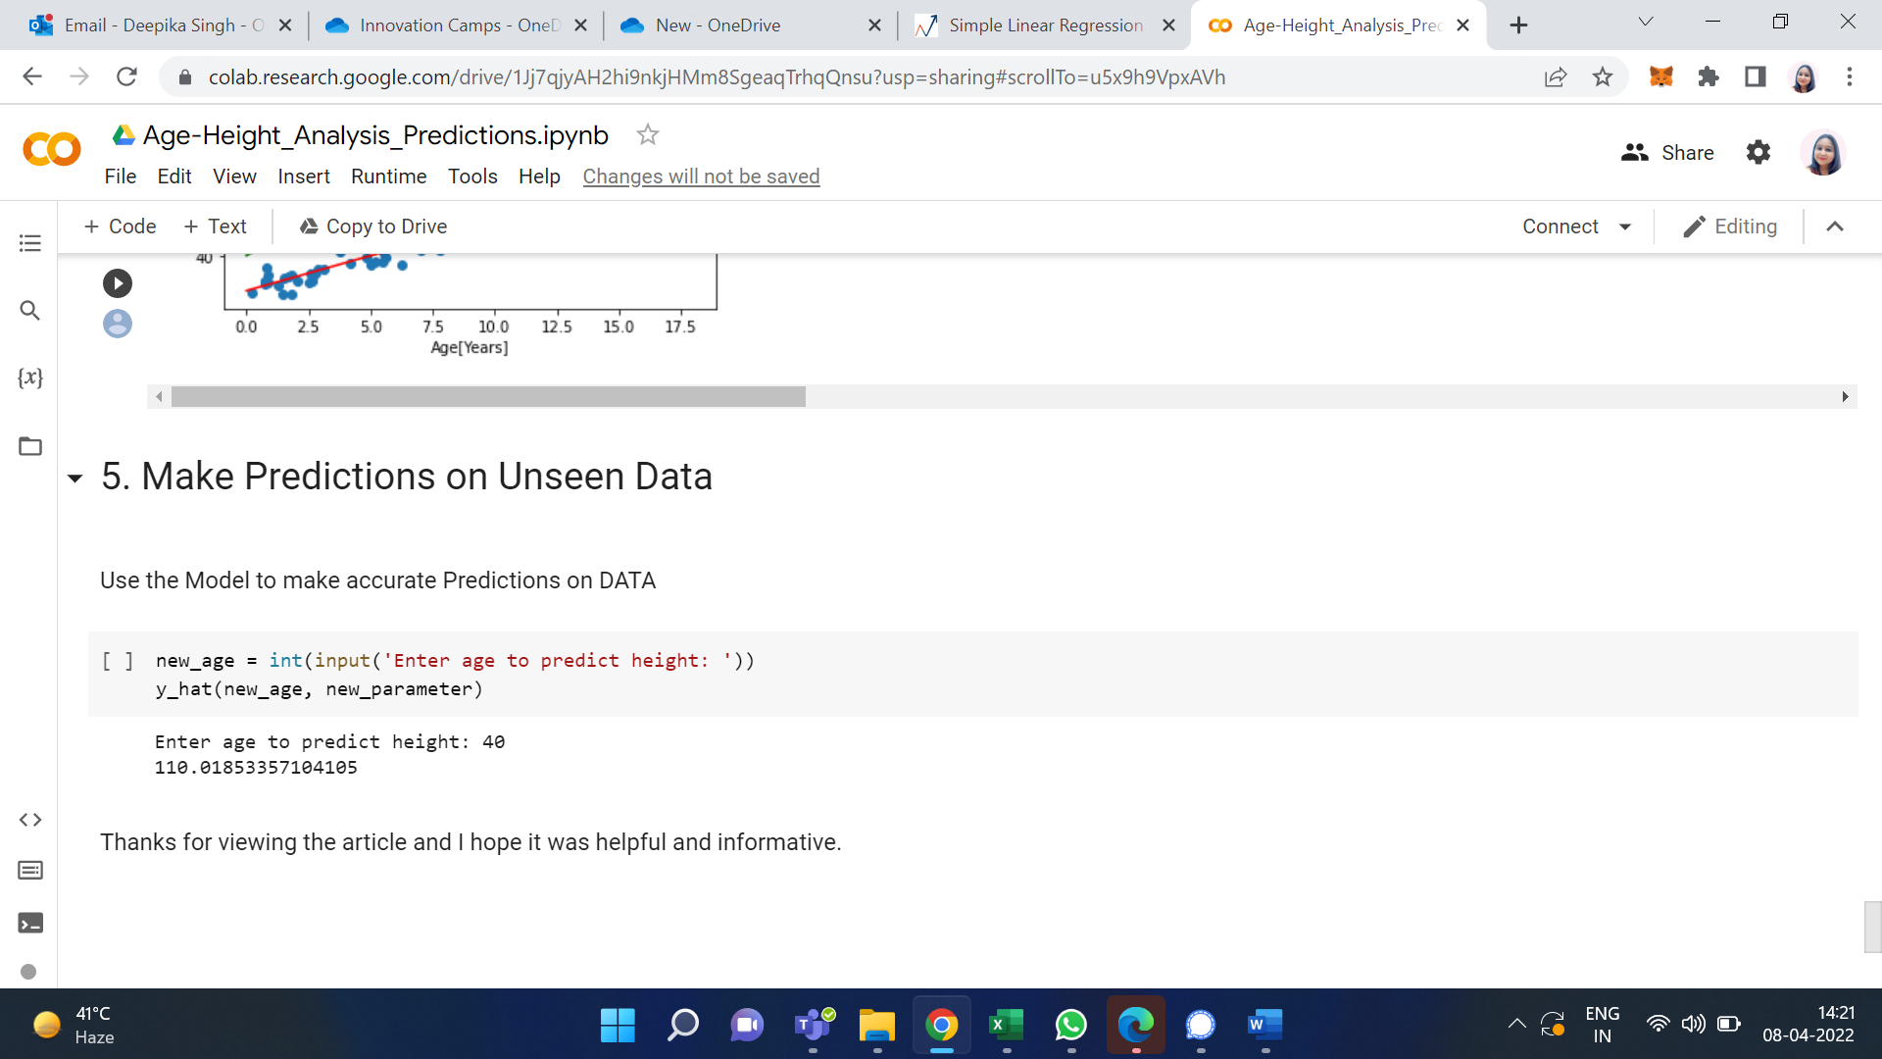

So, we can see for any given age we find the possible height in inches. Finally, we have successfully trained the model and with utmost accuracy.

**Output/Results snippet:**

<Paste your output/results screenshots here with a single line comment/description for each if there are multiple. Remove this part from your final document.>



**References:**

**<**Include at least 1 reference per activity where students can go and explore. Remove this part from your final document.**>**

* …….
* …….

# 

# Activity 2

## Aim: Evaluating Linear Regression model.

**Learning outcome:** Able to understand basic computer network technology.

**Duration:** 5 hour

**List of Hardware/Software requirements:**

1. …...
2. …...
3. …….

**Code/Program/Procedure (with comments):**

**Linear Regression with Python Scikit Learn**

In this section we will see how the Python Scikit-Learn library for machine learning can be used to implement regression functions. We will start with simple linear regression involving two variables and then we will move towards linear regression involving multiple variables.

**Simple Linear Regression**

In this regression task we will predict the percentage of marks that a student is expected to score based upon the number of hours they studied. This is a simple linear regression task as it involves just two variables.

Importing Libraries

To import necessary libraries for this task, execute the following import statements:

import pandas as pd

import numpy as np

import matplotlib.pyplot as plt

%matplotlib inline

Dataset

The dataset being used for this example has been made publicly available and can be downloaded from this link:

<https://drive.google.com/open?id=1oakZCv7g3mlmCSdv9J8kdSaqO5_6dIOw>

Note: This example was executed on a Windows based machine and the dataset was stored in "D:\datasets" folder. You can download the file in a different location as long as you change the dataset path accordingly.

The following command imports the CSV dataset using pandas:

dataset = pd.read_csv('D:\Datasets\student_scores.csv')

Now let's explore our dataset a bit. To do so, execute the following script:

dataset.shape

After doing this, you should see the following printed out:

(25, 2)

This means that our dataset has 25 rows and 2 columns. Let's take a look at what our dataset actually looks like. To do this, use the head() method:

dataset.head()

The above method retrieves the first 5 records from our dataset, which will look like this:

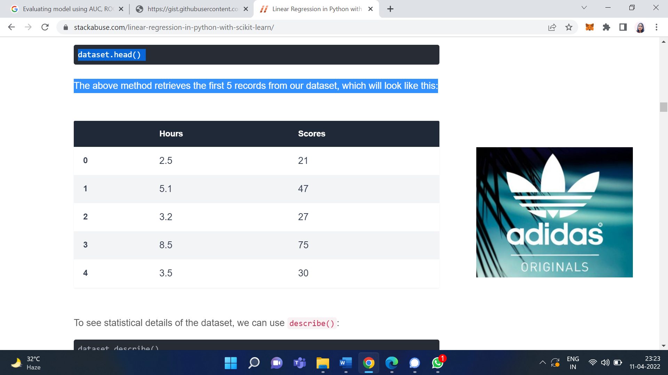

To see statistical details of the dataset, we can use describe():

dataset.describe()

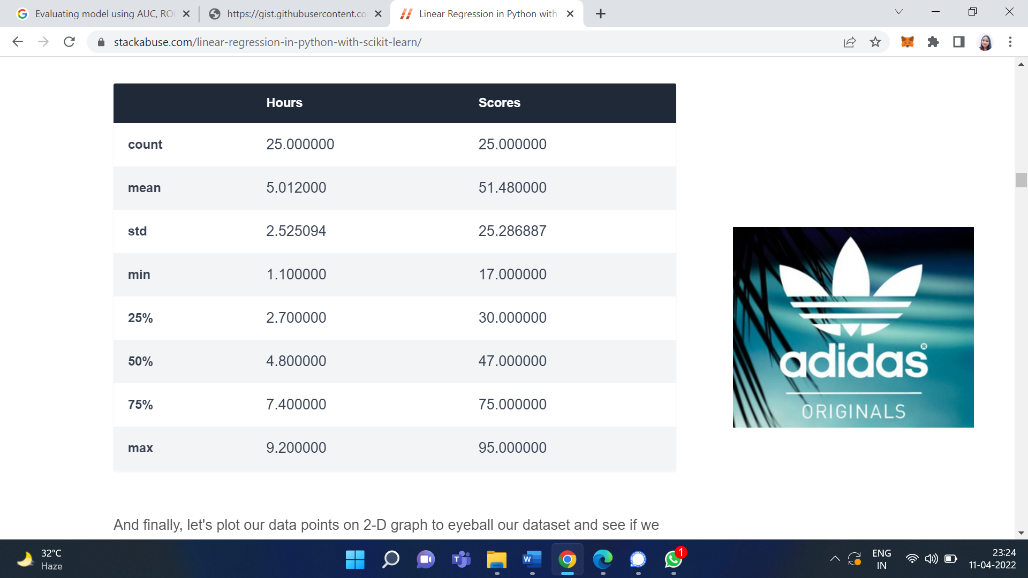

And finally, let's plot our data points on 2-D graph to eyeball our dataset and see if we can manually find any relationship between the data. We can create the plot with the following script:

dataset.plot(x='Hours', y='Scores', style='o')

plt.title('Hours vs Percentage')

plt.xlabel('Hours Studied')

plt.ylabel('Percentage Score')

plt.show()

In the script above, we use plot() function of the pandas dataframe and pass it the column names for x coordinate and y coordinate, which are "Hours" and "Scores" respectively.

The resulting plot will look like this:

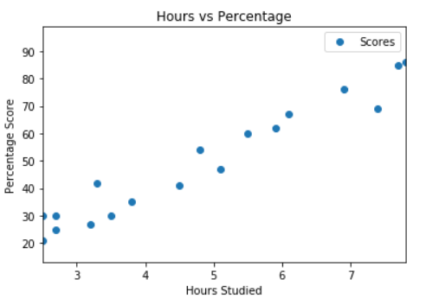

From the graph above, we can clearly see that there is a positive linear relation between the number of hours studied and percentage of score.

Preparing the Data

Now we have an idea about statistical details of our data. The next step is to divide the data into "attributes" and "labels". Attributes are the independent variables while labels are dependent variables whose values are to be predicted. In our dataset we only have two columns. We want to predict the percentage score depending upon the hours studied. Therefore our attribute set will consist of the "Hours" column, and the label will be the "Score" column. To extract the attributes and labels, execute the following script:

X = dataset.iloc[:, :-1].values

y = dataset.iloc[:, 1].values

The attributes are stored in the X variable. We specified "-1" as the range for columns since we wanted our attribute set to contain all the columns except the last one, which is "Scores". Similarly the y variable contains the labels. We specified 1 for the label column since the index for "Scores" column is 1. Remember, the column indexes start with 0, with 1 being the second column. In the next section, we will see a better way to specify columns for attributes and labels.

Now that we have our attributes and labels, the next step is to split this data into training and test sets. We'll do this by using Scikit-Learn's built-in train_test_split() method:

from sklearn.model_selection import train_test_split

X_train, X_test, y_train, y_test = train_test_split(X, y, test_size=0.2, random_state=0)

The above script splits 80% of the data to training set while 20% of the data to test set. The test_size variable is where we actually specify the proportion of test set.

**Training the Algorithm**

We have split our data into training and testing sets, and now is finally the time to train our algorithm. Execute following command:

from sklearn.linear_model import LinearRegression

regressor = LinearRegression()

regressor.fit(X_train, y_train)

With Scikit-Learn it is extremely straight forward to implement linear regression models, as all you really need to do is import the LinearRegression class, instantiate it, and call the fit() method along with our training data. This is about as simple as it gets when using a machine learning library to train on your data.

In the theory section we said that linear regression model basically finds the best value for the intercept and slope, which results in a line that best fits the data. To see the value of the intercept and slop calculated by the linear regression algorithm for our dataset, execute the following code.

**To retrieve the intercept:**

print(regressor.intercept_)

The resulting value you see should be approximately 2.01816004143.

For retrieving the slope (coefficient of x):

print(regressor.coef_)

The result should be approximately 9.91065648.

This means that for every one unit of change in hours studied, the change in the score is about 9.91%. Or in simpler words, if a student studies one hour more than they previously studied for an exam, they can expect to achieve an increase of 9.91% in the score achieved by the student previously.

**Making Predictions**

Now that we have trained our algorithm, it's time to make some predictions. To do so, we will use our test data and see how accurately our algorithm predicts the percentage score. To make pre-dictions on the test data, execute the following script:

y_pred = regressor.predict(X_test)

The y_pred is a numpy array that contains all the predicted values for the input values in the X_test series.

To compare the actual output values for X_test with the predicted values, execute the following script:

df = pd.DataFrame({'Actual': y_test, 'Predicted': y_pred})

df

The output looks like this:

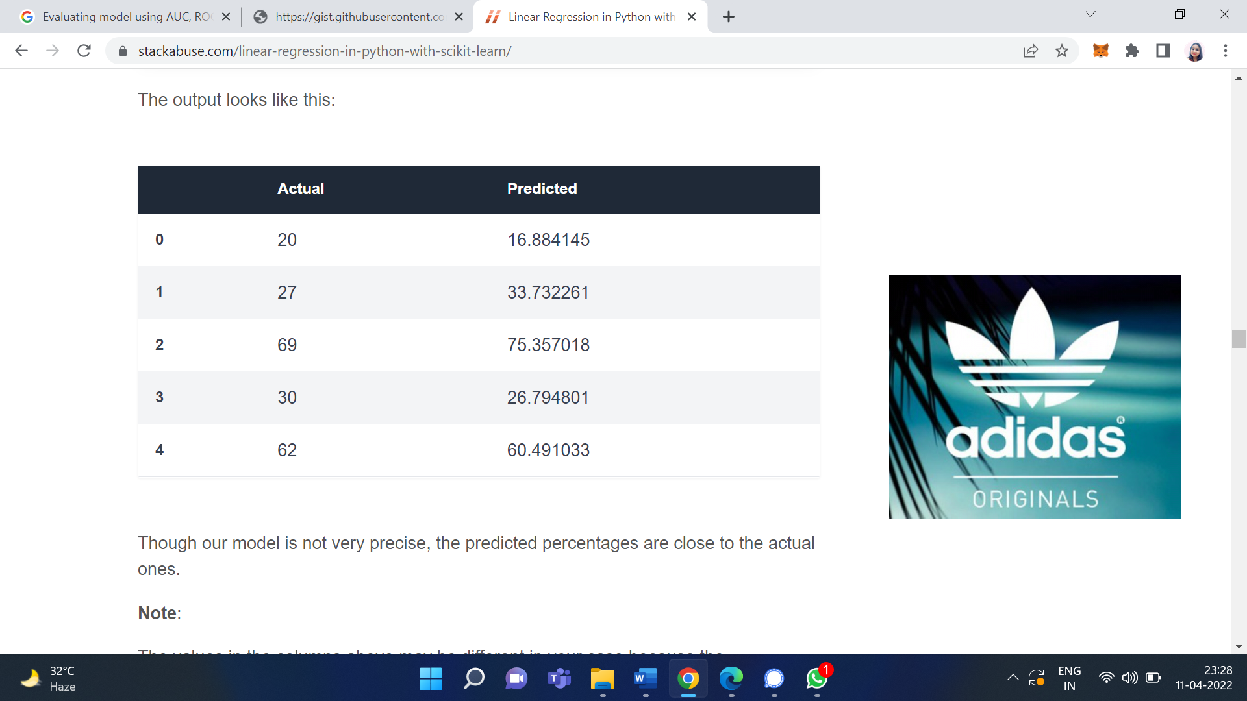

Though our model is not very precise, the predicted percentages are close to the actual ones.

Note:

The values in the columns above may be different in your case because the train_test_split function randomly splits data into train and test sets, and your splits are likely different from the one shown in this article.

**Evaluating the Algorithm**

The final step is to evaluate the performance of algorithm. This step is particularly important to compare how well different algorithms perform on a particular dataset. For regression algorithms, three evaluation metrics are commonly used:

1. Mean Absolute Error (MAE) is the mean of the absolute value of the errors. It is calculated as:

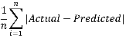

2. Mean Squared Error (MSE) is the mean of the squared errors and is calculated as:

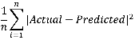

3. Root Mean Squared Error (RMSE) is the square root of the mean of the squared errors:

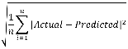

we don't have to perform these calculations manually. The Scikit-Learn library comes with pre-built functions that can be used to find out these values for us.

Let's find the values for these metrics using our test data. Execute the following code:

from sklearn import metrics

print('Mean Absolute Error:', metrics.mean_absolute_error(y_test, y_pred))

print('Mean Squared Error:', metrics.mean_squared_error(y_test, y_pred))

print('Root Mean Squared Error:', np.sqrt(metrics.mean_squared_error(y_test, y_pred)))

**Output/Results snippet:**

The output will look similar to this (but probably slightly different):

Mean Absolute Error: 4.183859899

Mean Squared Error: 21.5987693072

Root Mean Squared Error: 4.6474476121

You can see that the value of root mean squared error is 4.64, which is less than 10% of the mean value of the percentages of all the students i.e. 51.48. This means that our algorithm did a decent job.

# Activity 3

## Aim: Performing minmax scaling and standard scaling

**Learning outcome:** Able to understand basic computer network technology.

**Duration:** 5 hour

**List of Hardware/Software requirements:**

1. …...
2. …...
3. …….

**Code/Program/Procedure (with comments):**

StandardScaler follows Standard Normal Distribution (SND). Therefore, it makes mean = 0 and scales the data to unit variance.

MinMaxScaler scales all the data features in the range [0, 1] or else in the range [-1, 1] if there are negative values in the dataset. This scaling compresses all the inliers in the narrow range [0, 0.005].

In the presence of outliers, StandardScaler does not guarantee balanced feature scales, due to the influence of the outliers while computing the empirical mean and standard deviation. This leads to the shrinkage in the range of the feature values.

By using RobustScaler(), we can remove the outliers and then use either StandardScaler or MinMaxScaler for preprocessing the dataset.

How RobustScaler works:

class

sklearn.preprocessing.RobustScaler(

with_centering=True,

with_scaling=True,

quantile_range=(25.0, 75.0),

copy=True,

)

It scales features using statistics that are robust to outliers. This method removes the median and scales the data in the range between 1st quartile and 3rd quartile. i.e., in between 25th quantile and 75th quantile range. This range is also called an Interquartile range.

The median and the interquartile range are then stored so that it could be used upon future data using the transform method. If outliers are present in the dataset, then the median and the interquartile range provide better results and outperform the sample mean and variance.

Code: comparison between StandardScaler and MinMaxScaler.

# Importing libraries

import pandas as pd

import numpy as np

from sklearn import preprocessing

import matplotlib

import matplotlib.pyplot as plt

import seaborn as sns % matplotlib inline

matplotlib.style.use('fivethirtyeight')

# data

x = pd.DataFrame({

# Distribution with lower outliers

'x1': np.concatenate([np.random.normal(20, 2, 1000), np.random.normal(1, 2, 25)]),

# Distribution with higher outliers

'x2': np.concatenate([np.random.normal(30, 2, 1000), np.random.normal(50, 2, 25)]),

})

np.random.normal

scaler = preprocessing.RobustScaler()

robust_df = scaler.fit_transform(x)

robust_df = pd.DataFrame(robust_df, columns =['x1', 'x2'])

scaler = preprocessing.StandardScaler()

standard_df = scaler.fit_transform(x)

standard_df = pd.DataFrame(standard_df, columns =['x1', 'x2'])

scaler = preprocessing.MinMaxScaler()

minmax_df = scaler.fit_transform(x)

minmax_df = pd.DataFrame(minmax_df, columns =['x1', 'x2'])

fig, (ax1, ax2, ax3, ax4) = plt.subplots(ncols = 4, figsize =(20, 5))

ax1.set_title('Before Scaling')

sns.kdeplot(x['x1'], ax = ax1, color ='r')

sns.kdeplot(x['x2'], ax = ax1, color ='b')

ax2.set_title('After Robust Scaling')

sns.kdeplot(robust_df['x1'], ax = ax2, color ='red')

sns.kdeplot(robust_df['x2'], ax = ax2, color ='blue')

ax3.set_title('After Standard Scaling')

sns.kdeplot(standard_df['x1'], ax = ax3, color ='black')

sns.kdeplot(standard_df['x2'], ax = ax3, color ='g')

ax4.set_title('After Min-Max Scaling')

sns.kdeplot(minmax_df['x1'], ax = ax4, color ='black')

sns.kdeplot(minmax_df['x2'], ax = ax4, color ='g')

plt.show()

**Output/Results snippet:**

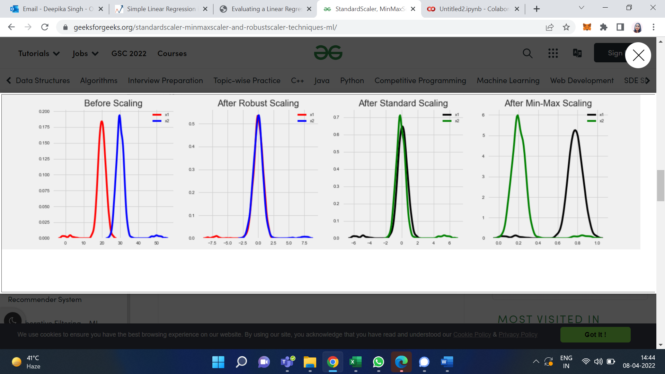

**References:**

**<**Include at least 1 reference per activity where students can go and explore. Remove this part from your final document.**>**

* …….
* …….

# Activity 4

## Aim: Implementing KNN in python using sklearn

**Learning outcome:** Able to understand basic computer network technology.

**Duration:** 5 hour

**List of Hardware/Software requirements:**

1. …...
2. …...
3. …….

**Code/Program/Procedure (with comments):**

Python's Scikit-Learn library can be used to implement the KNN algorithm in less than 20 lines of code. The download and installation instructions for Scikit learn library are available at [here](http://scikit-learn.org/stable/install.html).

Note: The code provided in this tutorial has been executed and tested with Python Jupyter notebook.

**The Dataset**

We are going to use the famous iris data set for our KNN example. The dataset consists of four attributes: sepal-width, sepal-length, petal-width and petal-length. These are the attributes of specific types of iris plant. The task is to predict the class to which these plants belong. There are three classes in the dataset: Iris-setosa, Iris-versicolor and Iris-virginica. Further details of the dataset are available [here](https://archive.ics.uci.edu/ml/datasets/Iris).

**Importing Libraries**

import numpy as np

import matplotlib.pyplot as plt

import pandas as pd

**Importing the Dataset**

To import the dataset and load it into our pandas dataframe, execute the following code:

url = "https://archive.ics.uci.edu/ml/machine-learning-databases/iris/iris.data"

# Assign colum names to the dataset

names = ['sepal-length', 'sepal-width', 'petal-length', 'petal-width', 'Class']

# Read dataset to pandas dataframe

dataset = pd.read_csv(url, names=names)

To see what the dataset actually looks like, execute the following command:

dataset.head()

Executing the above script will display the first five rows of our dataset as shown below:

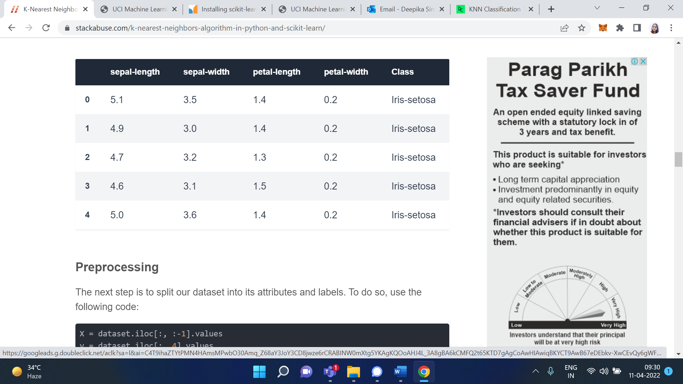

**Preprocessing**

The next step is to split our dataset into its attributes and labels. To do so, use the following code:

X = dataset.iloc[:, :-1].values

y = dataset.iloc[:, 4].values

The X variable contains the first four columns of the dataset (i.e. attributes) while y contains the labels.

**Train Test Split**

To avoid over-fitting, we will divide our dataset into training and test splits, which gives us a better idea as to how our algorithm performed during the testing phase. This way our algorithm is tested on un-seen data, as it would be in a production application.

To create training and test splits, execute the following script:

from sklearn.model_selection import train_test_split

X_train, X_test, y_train, y_test = train_test_split(X, y, test_size=0.20)

The above script splits the dataset into 80% train data and 20% test data. This means that out of total 150 records, the training set will contain 120 records and the test set contains 30 of those records.

**Feature Scaling**

Before making any actual predictions, it is always a good practice to scale the features so that all of them can be uniformly evaluated.

The gradient descent algorithm (which is used in neural network training and other machine learning algorithms) also converges faster with normalized features.

The following script performs feature scaling:

from sklearn.preprocessing import StandardScaler

scaler = StandardScaler()

scaler.fit(X_train)

X_train = scaler.transform(X_train)

X_test = scaler.transform(X_test)

**Training and Predictions**

It is extremely straight forward to train the KNN algorithm and make predictions with it, especially when using Scikit-Learn.

from sklearn.neighbors import KNeighborsClassifier

classifier = KNeighborsClassifier(n_neighbors=5)

classifier.fit(X_train, y_train)

The first step is to import the KNeighborsClassifier class from the sklearn.neighbors library. In the second line, this class is initialized with one parameter, i.e. n_neigbours. This is basically the value for the K. There is no ideal value for K and it is selected after testing and evaluation, however to start out, 5 seems to be the most commonly used value for KNN algorithm.

The final step is to make predictions on our test data. To do so, execute the following script:

y_pred = classifier.predict(X_test)

**Evaluating the Algorithm**

For evaluating an algorithm, confusion matrix, precision, recall and f1 score are the most commonly used metrics. The confusion_matrix and classification_report methods of the sklearn.metrics can be used to calculate these metrics. Take a look at the following script:

from sklearn.metrics import classification_report, confusion_matrix

print(confusion_matrix(y_test, y_pred))

print(classification_report(y_test, y_pred))

The output of the above script looks like this:

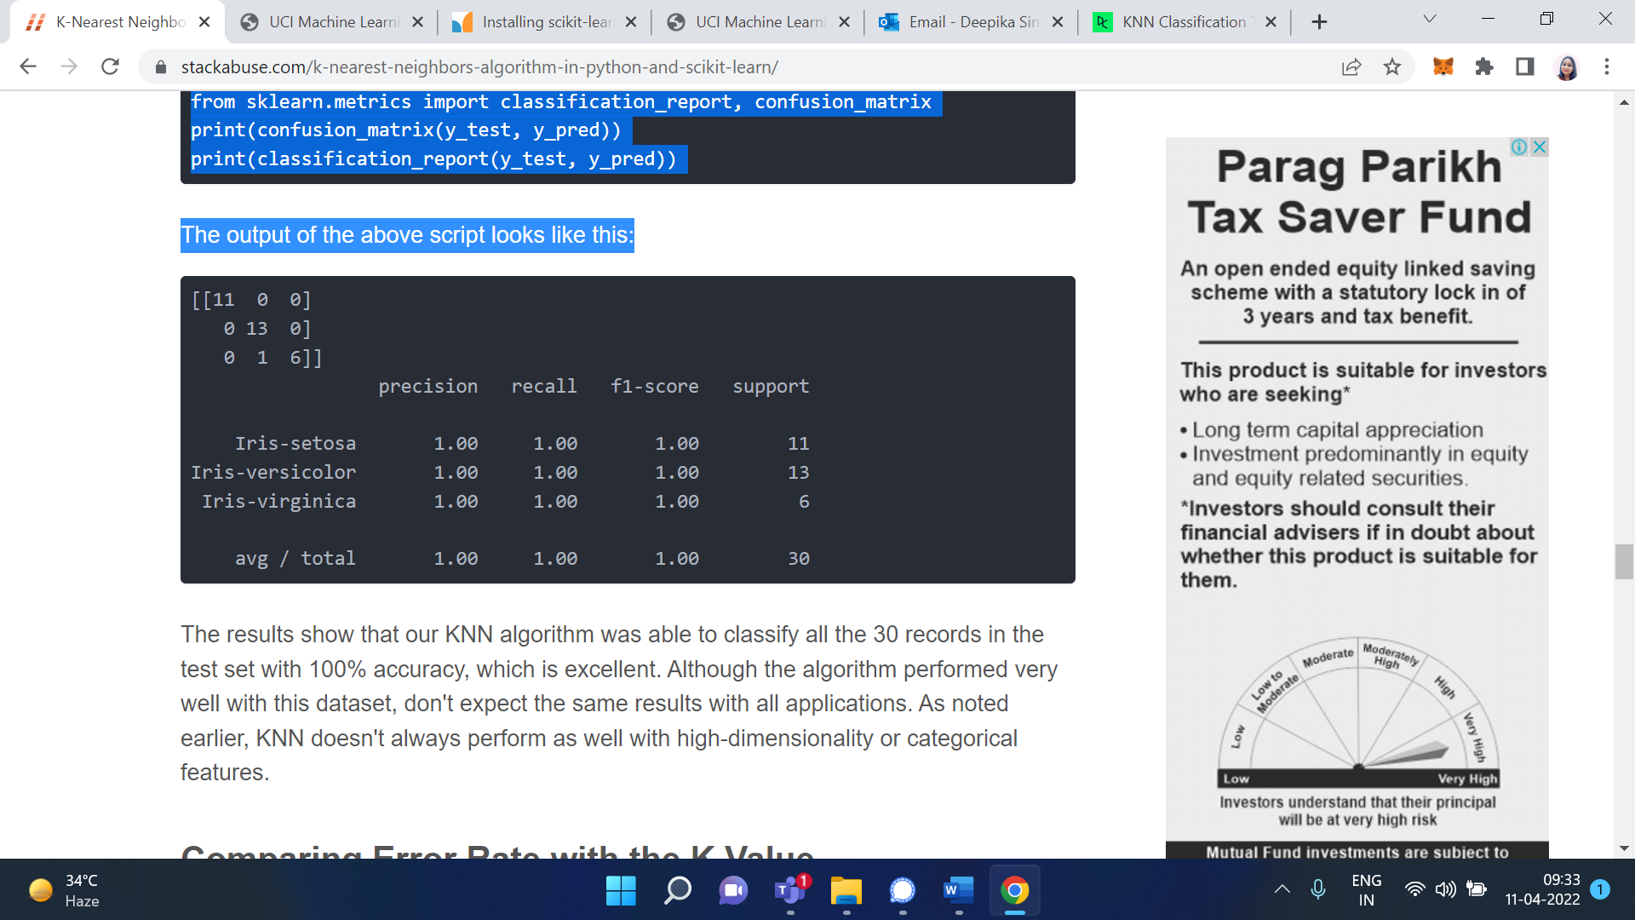

The results show that our KNN algorithm was able to classify all the 30 records in the test set with 100% accuracy, which is excellent. Although the algorithm performed very well with this dataset, don't expect the same results with all applications. As noted earlier, KNN doesn't always perform as well with high-dimensionality or categorical features.

**Comparing Error Rate with the K Value**

In the training and prediction section we said that there is no way to know beforehand which value of K that yields the best results in the first go. We randomly chose 5 as the K value and it just happen to result in 100% accuracy.

One way to help you find the best value of K is to plot the graph of K value and the corresponding error rate for the dataset.

In this section, we will plot the mean error for the predicted values of test set for all the K values between 1 and 40.

To do so, let's first calculate the mean of error for all the predicted values where K ranges from 1 and 40. Execute the following script:

error = []

# Calculating error for K values between 1 and 40

for i in range(1, 40):

knn = KNeighborsClassifier(n_neighbors=i)

knn.fit(X_train, y_train)

pred_i = knn.predict(X_test)

error.append(np.mean(pred_i != y_test))

The above script executes a loop from 1 to 40. In each iteration the mean error for predicted values of test set is calculated and the result is appended to the error list.

The next step is to plot the error values against K values. Execute the following script to create the plot:

plt.figure(figsize=(12, 6))

plt.plot(range(1, 40), error, color='red', linestyle='dashed', marker='o',

markerfacecolor='blue', markersize=10)

plt.title('Error Rate K Value')

plt.xlabel('K Value')

plt.ylabel('Mean Error')

**Output/Results snippet:**

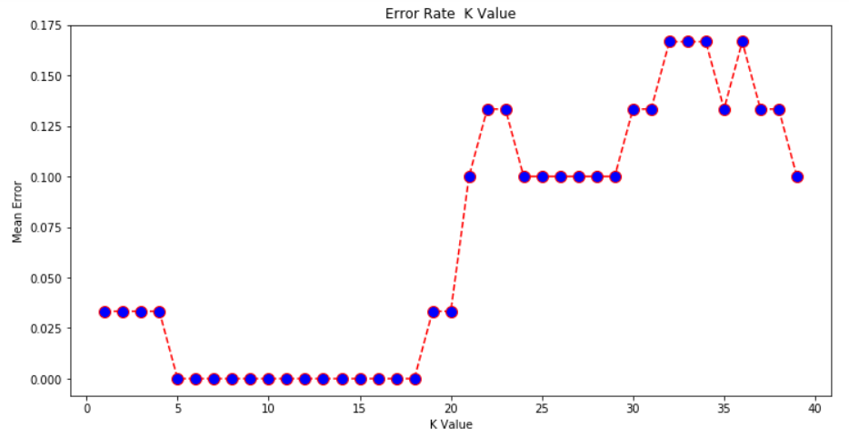

From the output we can see that the mean error is zero when the value of the K is between 5 and 18. I would advise you to play around with the value of K to see how it impacts the accuracy of the predictions.

# Activity 5

## Aim: Evaluation of KNN model in python, and visualizing result.

**Learning outcome:** Able to understand basic computer network technology.

**Duration:** 5 hour

**List of Hardware/Software requirements:**

1. …...
2. …...
3. …….

**Code/Program/Procedure (with comments):**

K-nearest neighbors (kNN) is a supervised machine learning algorithm that can be used to solve both classification and regression tasks. I see kNN as an algorithm that comes from real life. People tend to be effected by the people around them. Our behaviour is guided by the friends we grew up with. Our parents also shape our personality in some ways. If you grow up with people who love sports, it is higly likely that you will end up loving sports. There are ofcourse exceptions. kNN works similarly.

**The value of a data point is determined by the data points around it.**

* If you have one very close friend and spend most of your time with him/her, you will end up sharing similar interests and enjoying same things. That is kNN with k=1.
* If you always hang out with a group of 5, each one in the group has an effect on your behavior and you will end up being the average of 5. That is kNN with k=5.

kNN classifier determines the class of a data point by majority voting principle. If k is set to 5, the classes of 5 closest points are checked. Prediction is done according to the majority class. Similarly, kNN regression takes the mean value of 5 closest points.

We observe people who are close but how data points are determined to be close? The distance between data points is measured. There are many methods to measure the distance. Euclidean distance (minkowski distance with p=2) is one of most commonly used distance measurement. The figure below shows how to calculate euclidean distance between two points in a 2-dimensional space. It is calculated using the square of the difference between x and y coordinates of the points.

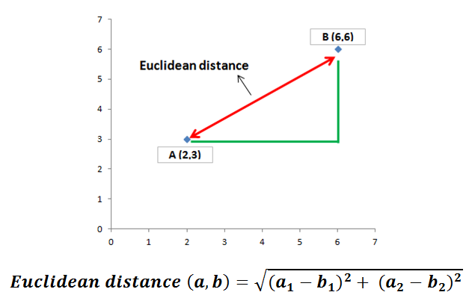

In the case above, euclidean distance is the square root of (16 + 9) which is 5. Euclidean distance in two dimensions remind us the famous pythagorean theorem.

It seems very simple for two points in 2-dimensional space. Each dimension represents a feauture in the dataset. We typically have many samples with many features. To be able to explain the concept clearly, I will go over an example in 2-dimensional space.

Let’s start with importing libraries:

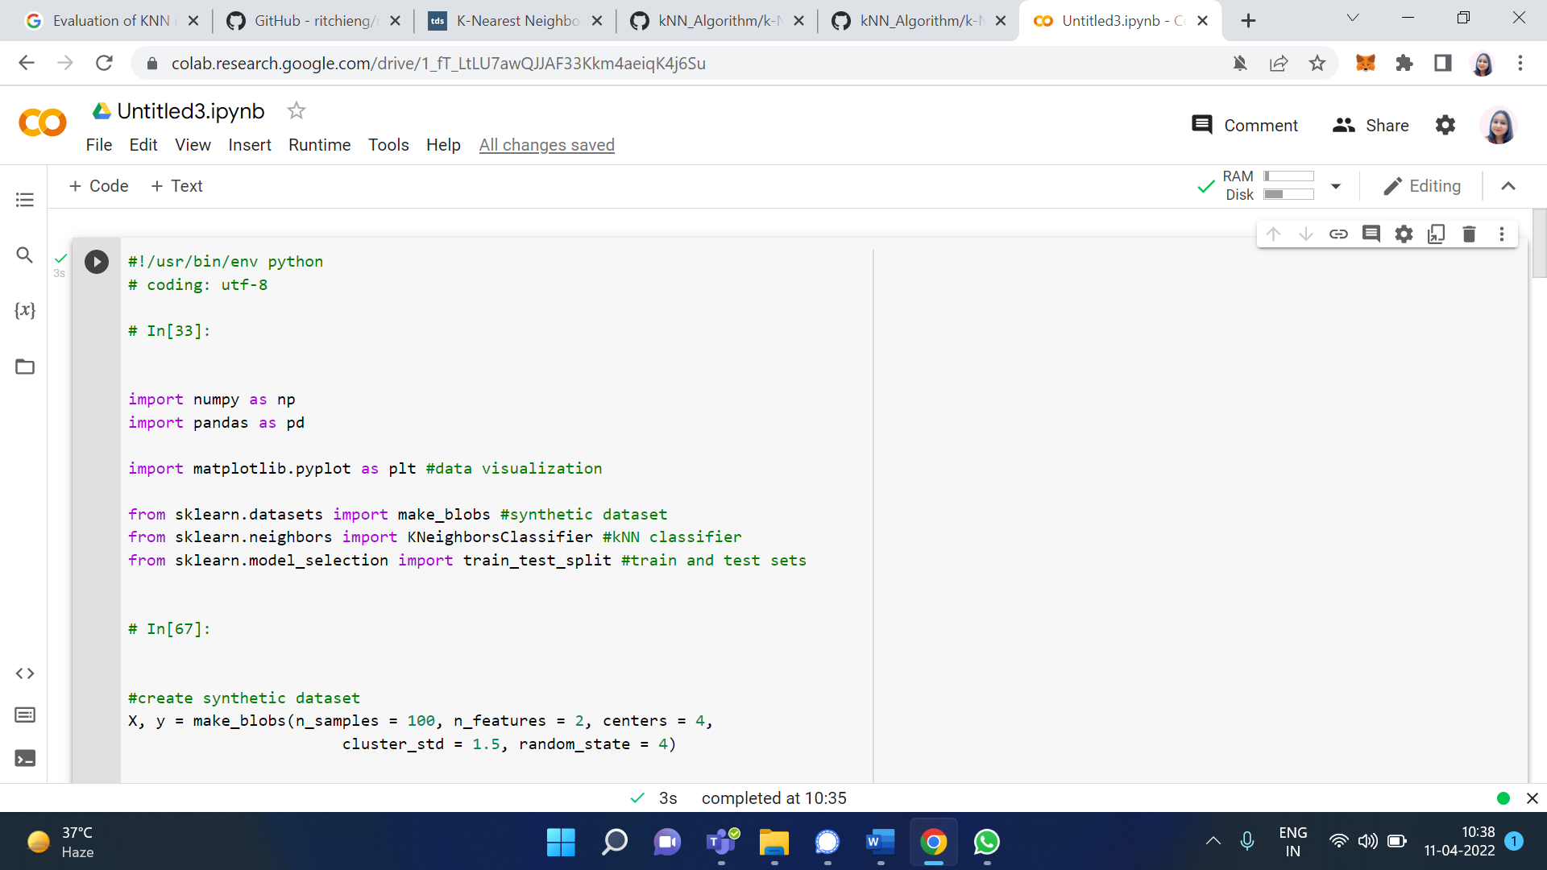

Scikit-learn provides many useful functions to create synthetic datasets which are very helpful for practicing machine learning algorithms. I will use make_blobs function.

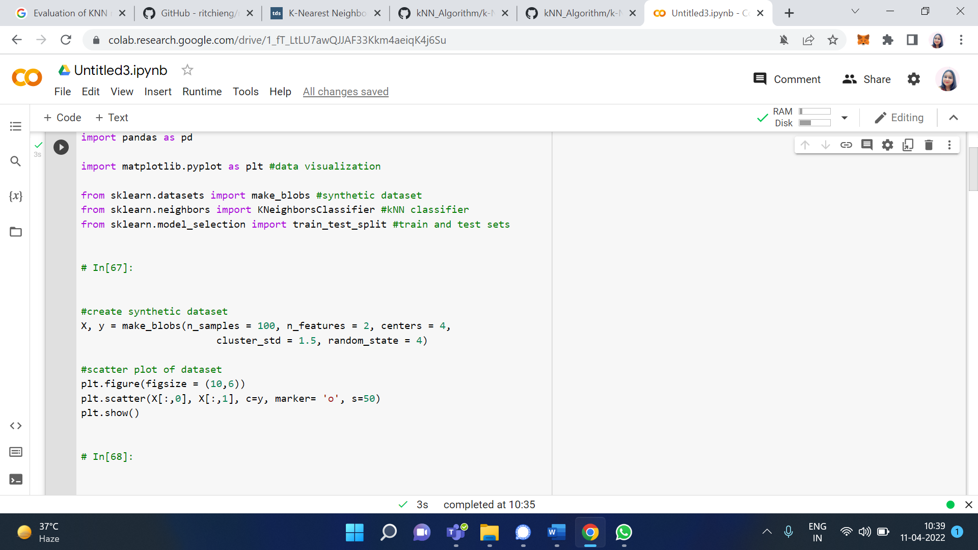

This code creates a dataset with 100 samples divided into 4 classes and the number of features is 2. Number of samples, features and classes can easily be adjusted using related parameters. We can also adjust how much each cluster (or class) is spread. Let’s visualize this synthetic data set:

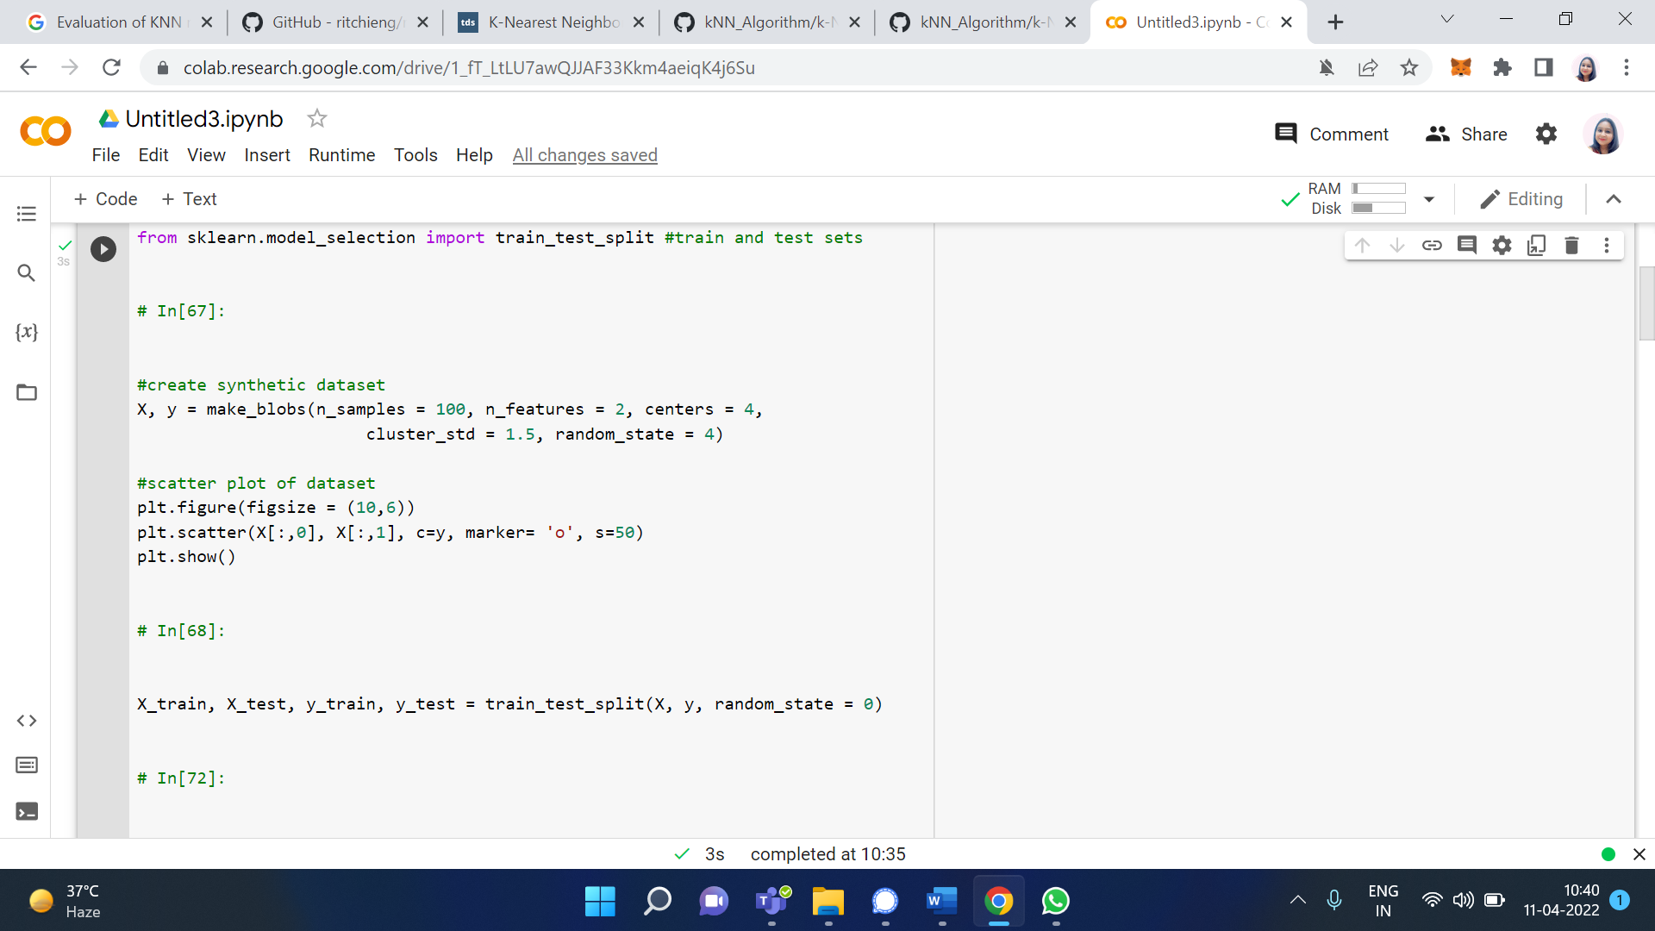

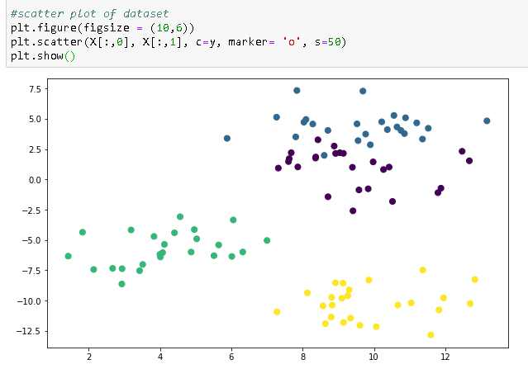

For any supervised machine learning algorithm, it is very important to divide dataset into train and test sets. We first train the model and test it using different parts of dataset. If this separation is not done, we basically test the model with some data it already knows. We can easily do this separation using train_test_split function.

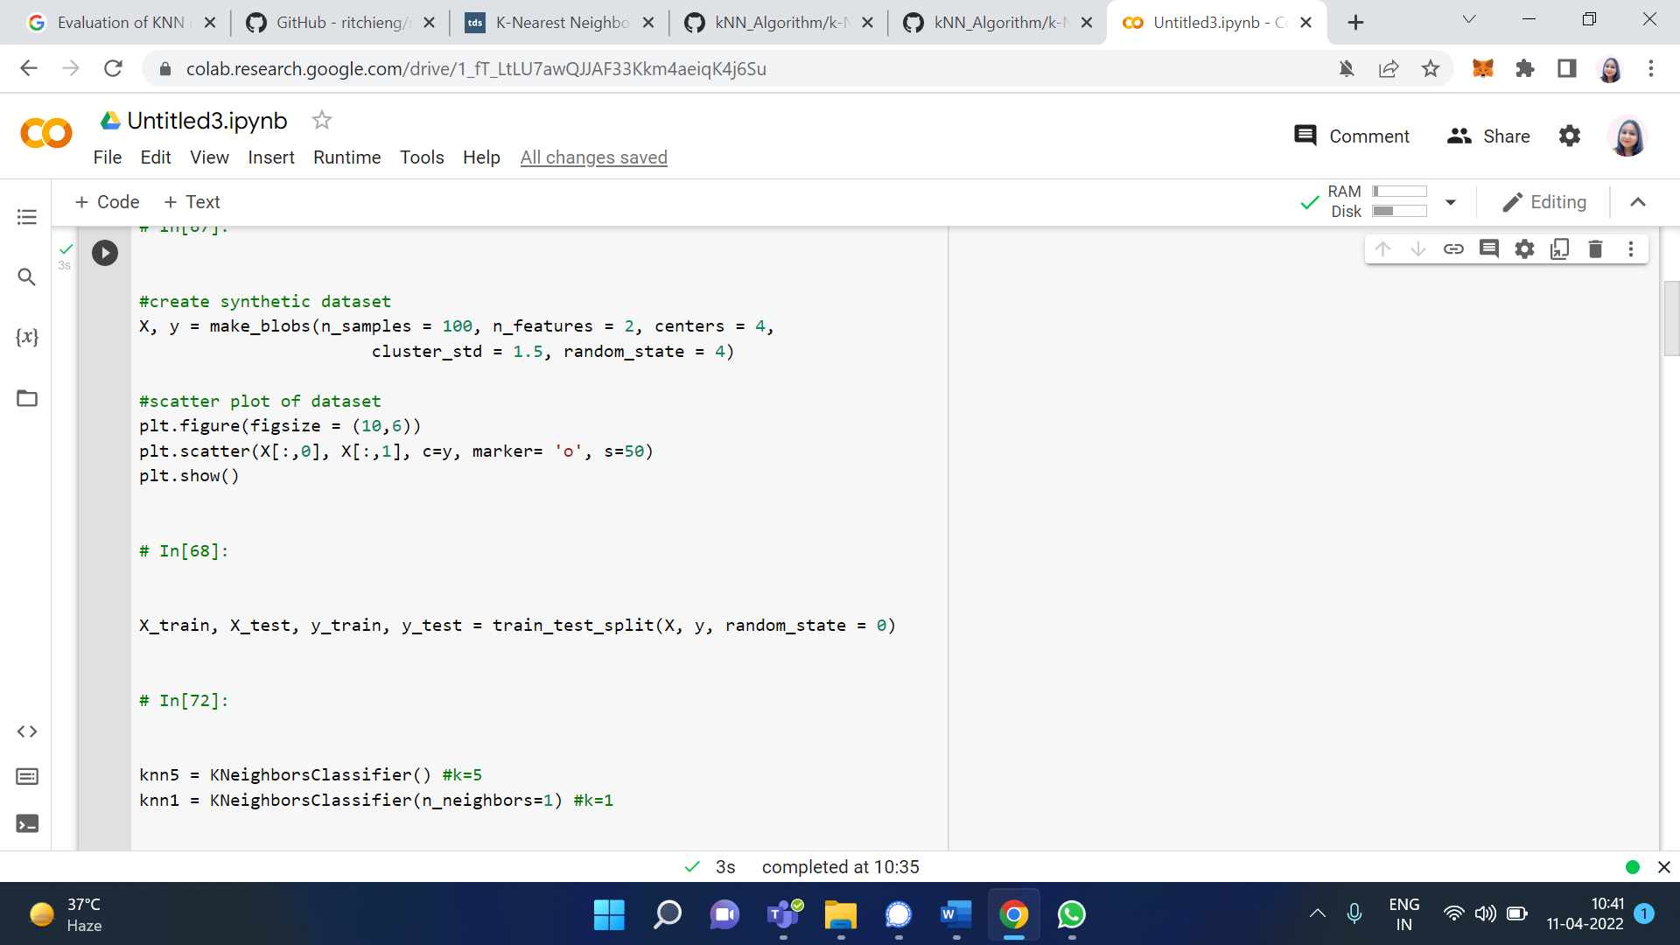

We can specify how much of the original data is used for train or test sets using train_size or test_size parameters, respectively. Default separation is 75% for train set and 25% for test set.

Then we create a kNN classifier object. To show the difference between the importance of k value, I create two classifiers with k values 1 and 5. Then these models are trained using train set. n_neighbors parameter is used to select k value. Default value is 5 so it does not have to be explicitly written.

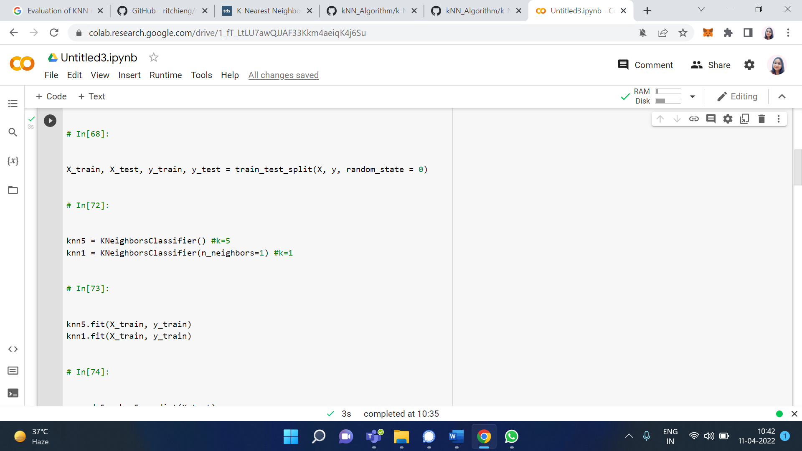

Then we predict the target values in the test set and compare with actual values.

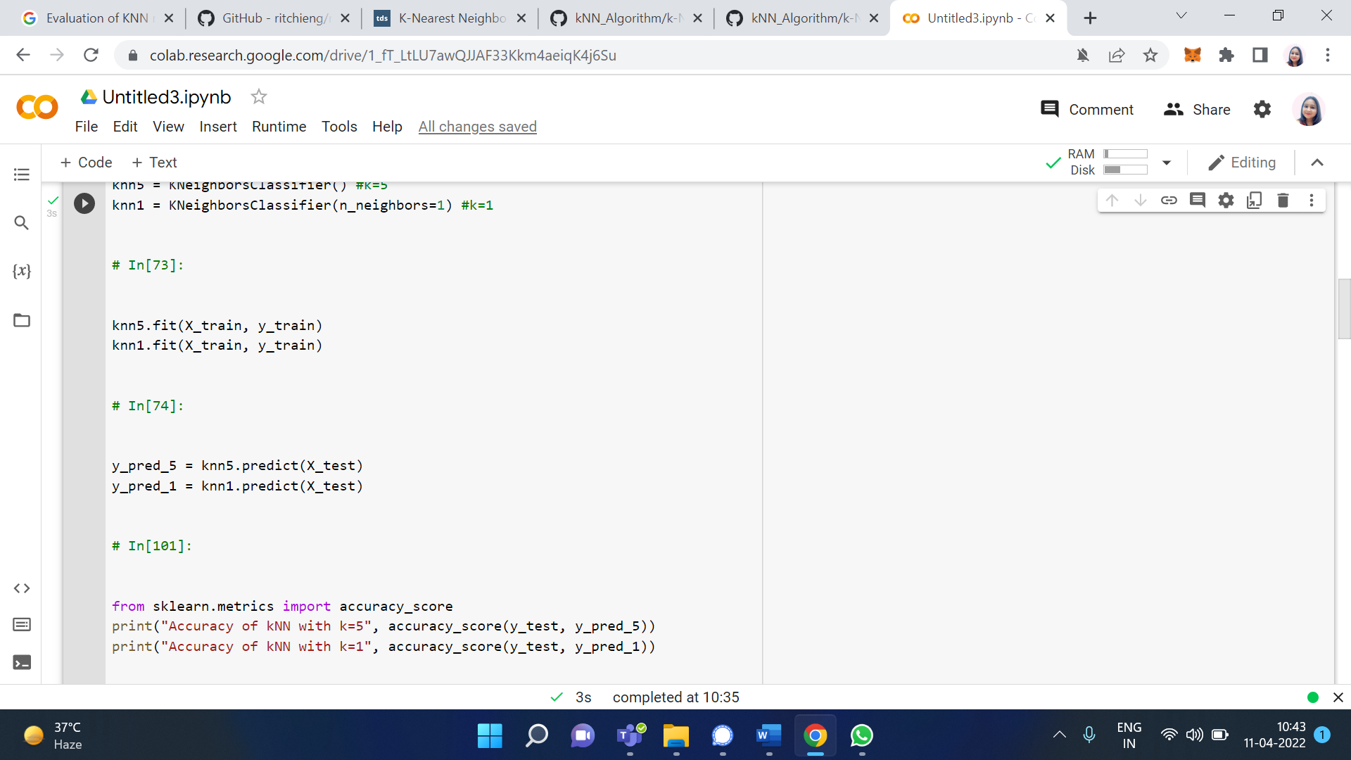

In order to see the effect of k values, let’s visualize test set and predicted values with k=5 and k=1.

**Output/Results snippet:**

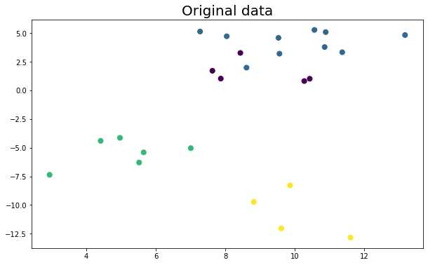

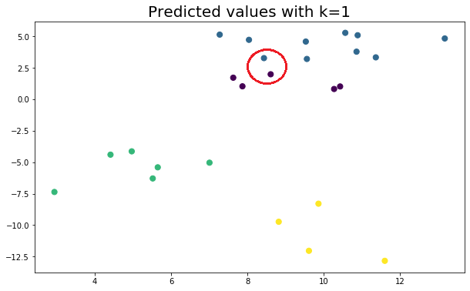

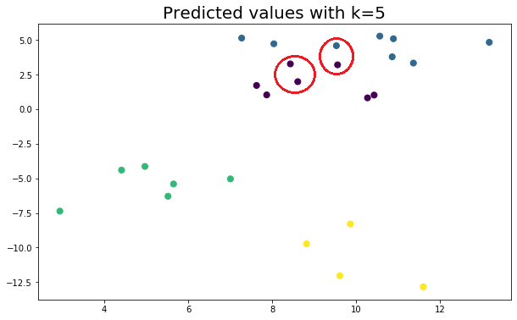

The result seems to be very similar because we used a substantially small dataset. However, even on small datasets, different k values predict some points differently.

# Activity 6

## Aim: Evaluating model using AUC, ROC curve.

**Learning outcome:** Able to understand basic computer network technology.

**Duration:** 5 hour

**List of Hardware/Software requirements:**

1. …...
2. …...
3. …….

**Code/Program/Procedure (with comments):**

Using ROC and AUC in Python

You’ll use the [White wine quality dataset](https://www.kaggle.com/piyushagni5/white-wine-quality) for the practical part. Here’s how to load it with Python:

The first couple of rows look like this:

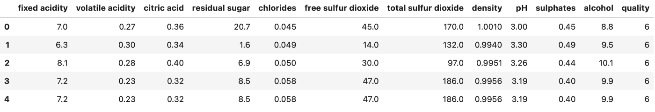

Initially, this is not a binary classification dataset, but you can convert it to one. Let’s say the wine is Good if the quality is 7 or above, and Bad otherwise:

df['quality'] = ['Good' if quality >= 7 else 'Bad' for quality in df['quality']]

There’s your binary classification dataset. Let’s visualize the counts of good and bad wines next. Here’s the code:

ax = df['quality'].value_counts().plot(kind='bar', figsize=(10, 6), fontsize=13, color='#087E8B')

ax.set_title('Counts of Bad and Good vines', size=20, pad=30)

ax.set_ylabel('Count', fontsize=14)

for i in ax.patches:

ax.text(i.get_x() + 0.19, i.get_height() + 100, str(round(i.get_height(), 2)), fontsize=15)

And here’s the chart:

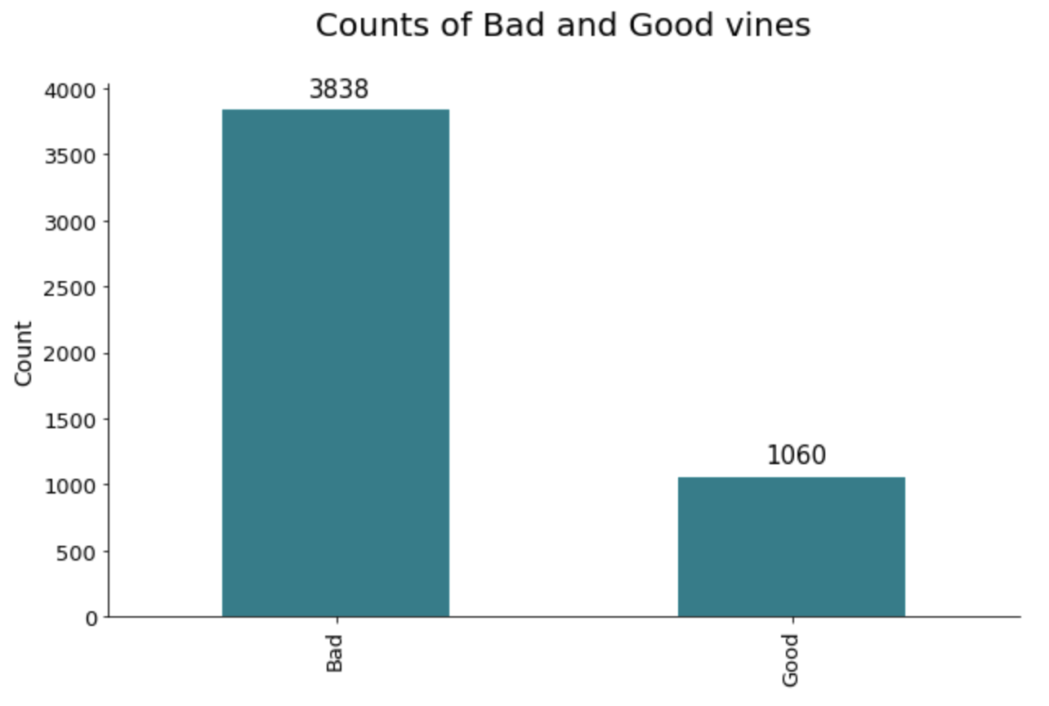

And there’s nothing more to do with regards to preparation. You can make a train/test split next:

from sklearn.model_selection import train_test_split

X = df.drop('quality', axis=1)

y = df['quality']

X_train, X_test, y_train, y_test = train_test_split(

X, y, test_size=0.25, random_state=42

)

Great! The snippet below shows you how to train logistic regression, decision tree, random forests, and extreme gradient boosting models. It also shows you how to grab probabilities for the positive class. It will come in handy later:

from sklearn.linear_model import LogisticRegression

from sklearn.tree import DecisionTreeClassifier

from sklearn.ensemble import RandomForestClassifier

from xgboost import XGBClassifier

model_lr = LogisticRegression().fit(X_train, y_train)

probs_lr = model_lr.predict_proba(X_test)[:, 1]

model_dt = DecisionTreeClassifier().fit(X_train, y_train)

probs_dt = model_dt.predict_proba(X_test)[:, 1]

model_rf = RandomForestClassifier().fit(X_train, y_train)

probs_rf = model_rf.predict_proba(X_test)[:, 1]

model_xg = XGBClassifier().fit(X_train, y_train)

probs_xg = model_xg.predict_proba(X_test)[:, 1]

You can visualize the ROC curves and calculate the AUC now. The only requirement is to remap the Good and Bad class names to 1 and 0, respectively.

The following code snippet visualizes the ROC curve for the four trained models and shows their AUC score on the legend:

from sklearn.metrics import roc_auc_score, roc_curve

y_test_int = y_test.replace({'Good': 1, 'Bad': 0})

auc_lr = roc_auc_score(y_test_int, probs_lr)

fpr_lr, tpr_lr, thresholds_lr = roc_curve(y_test_int, probs_lr)

auc_dt = roc_auc_score(y_test_int, probs_dt)

fpr_dt, tpr_dt, thresholds_dt = roc_curve(y_test_int, probs_dt)

auc_rf = roc_auc_score(y_test_int, probs_rf)

fpr_rf, tpr_rf, thresholds_rf = roc_curve(y_test_int, probs_rf)

auc_xg = roc_auc_score(y_test_int, probs_xg)

fpr_xg, tpr_xg, thresholds_xg = roc_curve(y_test_int, probs_xg)

plt.figure(figsize=(12, 7))

plt.plot(fpr_lr, tpr_lr, label=f'AUC (Logistic Regression) = {auc_lr:.2f}')

plt.plot(fpr_dt, tpr_dt, label=f'AUC (Decision Tree) = {auc_dt:.2f}')

plt.plot(fpr_rf, tpr_rf, label=f'AUC (Random Forests) = {auc_rf:.2f}')

plt.plot(fpr_xg, tpr_xg, label=f'AUC (XGBoost) = {auc_xg:.2f}')

plt.plot([0, 1], [0, 1], color='blue', linestyle='--', label='Baseline')

plt.title('ROC Curve', size=20)

plt.xlabel('False Positive Rate', size=14)

plt.ylabel('True Positive Rate', size=14)

plt.legend();

**Output/Results snippet:**

Here’s the corresponding visualization:

